1. Get Employee ID’s of those employees who didn’t receive incentives
SELECT e.empno, e.ename
FROM emp e
LEFT JOIN incentives i
ON e.empno = i.empno
WHERE i.empno IS NULL;
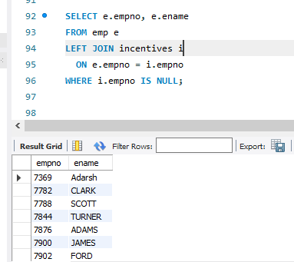

2. List the name of the managers with the most employees
SELECT m.ename, count(*)
FROM emp e,emp m
WHERE e.mgr_no = m.empno
GROUP BY m.ename
HAVING count(*) =(SELECT MAX(mycount)
from (SELECT COUNT(*) mycount
FROM emp
GROUP BY mgr_no) a);
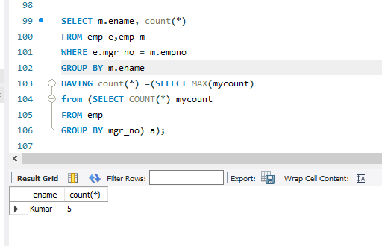
3. Display those managers name whose salary is more than average salary of his
employee?
SELECT *
FROM emp m
WHERE m.empno IN
(SELECT mgr_no
FROM emp)
AND m.sal >
(SELECT avg(e.sal)
FROM emp e
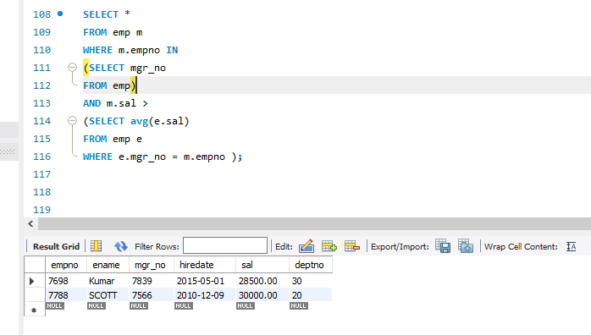
WHERE e.mgr_no = m.empno );

4. SQL Query to find the employee details who got second maximum incentive in
Febrauary 2019.
select *
from emp e,incentives i
where e.empno=i.empno and 2 = ( select count(*)
from incentives j
where i.incentive_amount <= j.incentive_amount );

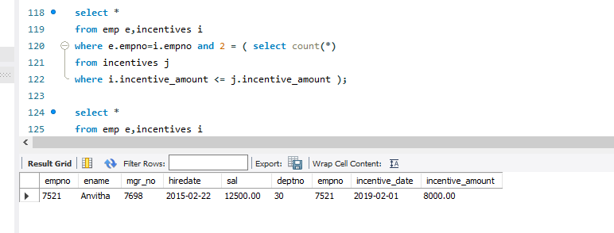

5. Display those employees who are working in the same dept where his manager
is work. ?
SELECT *
FROM EMP E
WHERE E.DEPTNO = (SELECT E1.DEPTNO
FROM EMP E1
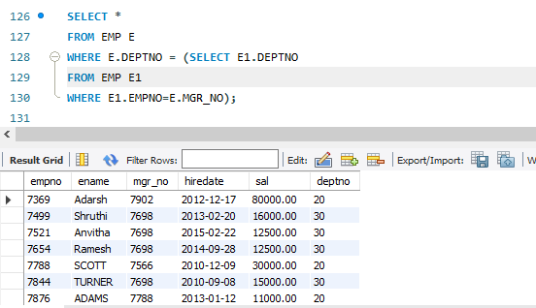
WHERE E1.EMPNO=E.MGR_NO);
6. Retrieve the employee numbers of all employees who work on project located
in Bengaluru, Hyderabad, or Mysuru
select e.empno
from emp e, assigned_to a, project p
where e.empno=a.empno and a.pno=p.pno and
p.ploc in ('Bengaluru','Hyderabad','Mysuru');
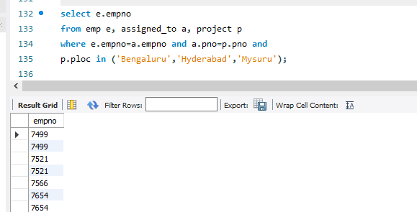

7. Write a SQL query to find those employees whose net pay are higher than or
equal to the salary of any other employee in the company
SELECT DISTINCT e.ename
FROM emp e
LEFT JOIN incentives i ON e.empno = i.empno
GROUP BY e.empno, e.ename, e.deptno, e.sal
HAVING (e.sal + IFNULL(SUM(i.incentive_amount), 0)) >= ANY (
SELECT sal
FROM emp e1
WHERE e.deptno = e1.deptno);
